# Laboratory 7

**Title of the Laboratory Exercise: Nested queries and Join queries**

1. **Introduction and Purpose of Experiment**

Nesting of queries within another one is known as a nested queries. The query within another is known as a subquery. The statement containing a subquery is called a Parent Statement. The parent statement uses the rows returned by the subquery. SQL Join is used for combining column from two or more tables by using values common to both tables. Join Keyword is used in SQL queries. By doing this lab, students will be able to implement nested queries and join queries.

1. **Aim and Objectives**

**Aim**

* To design and implement nested queries and join queries using SQL commands

**Objectives**

At the end of this lab, the student will be able to

* Design nested queries and join queries for the given problem statement
* Execute the nested queries and join queries

1. **Experimental Procedure**
   * + Analyse the problem statement
     + Create tables with appropriate attributes
     + Insert attribute values into the table
     + Design nested queries and join queries
     + Execute the SQL commands
     + Test the executed commands
     + Document the Results
     + Analyse and discuss the outcomes of your experiment
2. **Questions**
   1. Create a tables for the given relational schema. Assume appropriate data type, and key constraints for each field.

Player (Name, Id, TeamNo, Score)

Team (TeamNo, TeamName)

* 1. Write the appropriate query for the following statements using SQL commands
     1. Find the names of all the players who are in the same Team of ‘Smith’ (use nested query)
     2. Display the information about players who got Scores more than any player in TeamNo=1 (use nested query)
     3. Display the players and Team details , in which the *TeamNo* is same in both the playersand *Team* (without join)
     4. Display the players and Team details , in which the *TeamNo* is same in both the playersand *Team* (use join)
     5. Display the players and Team details , in which the *TeamNo* is same in both the playersand *Team* (use natural join)
     6. Display the players and their team names, in which the *TeamNo* is same in both the playersand *Team* (use left outer join)
     7. Display the team names and the players involved, in which the *TeamNo* is same in both the playersand *Team* (use right outer join)
  2. Create suitable front end for querying and displaying the results

1. **Presentation of Results**

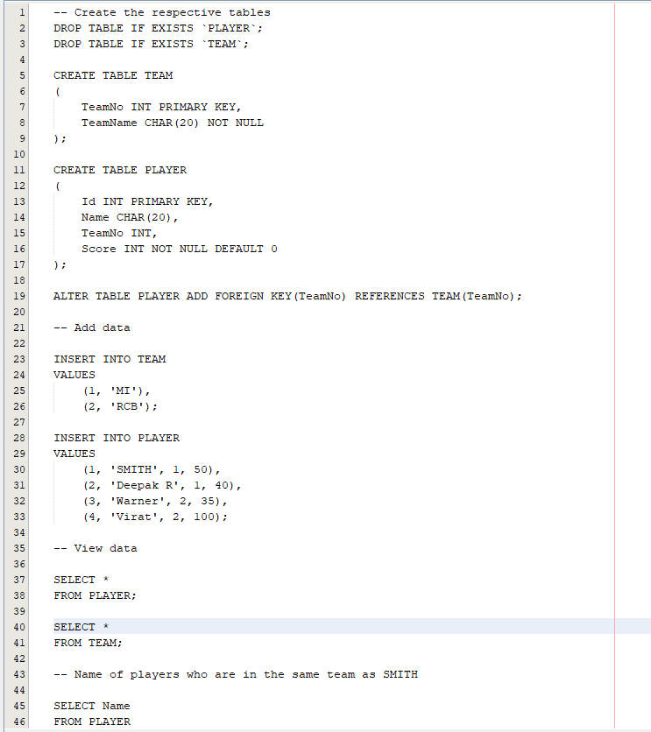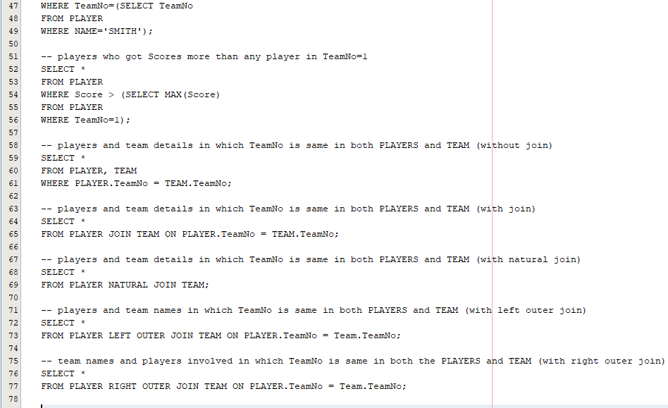

Figure 0‑0 Mysql Commands for given Problem

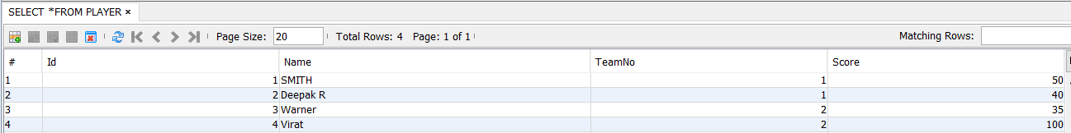

Figure 0‑1 PLAYER Table

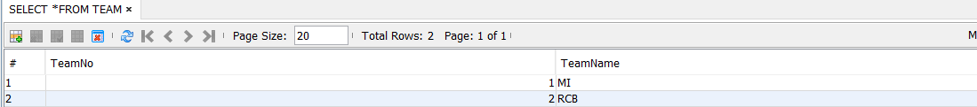

Figure 0‑2 TEAM Table

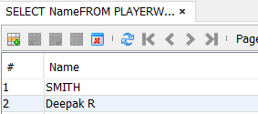

Figure 0‑3 Name of players who are in the same team as SMITH



Figure 0‑4 players who got Scores more than any player in TeamNo=1

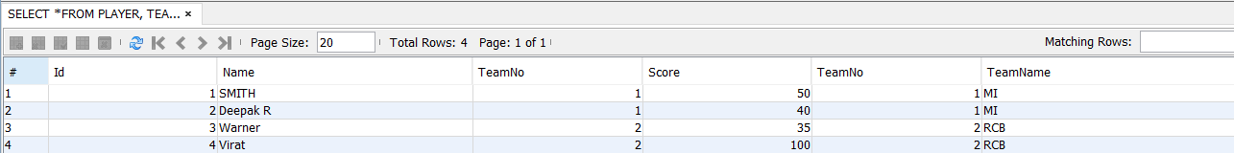

Figure 0‑5 players and team details in which TeamNo is same in both PLAYERS and TEAM (without join)

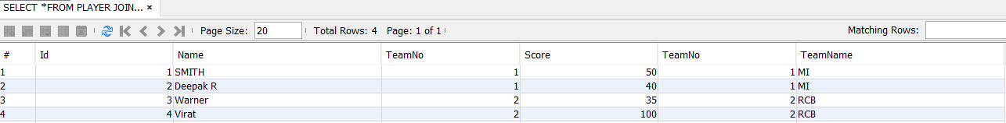

Figure 0‑6 players and team details in which TeamNo is same in both PLAYERS and TEAM (with join)

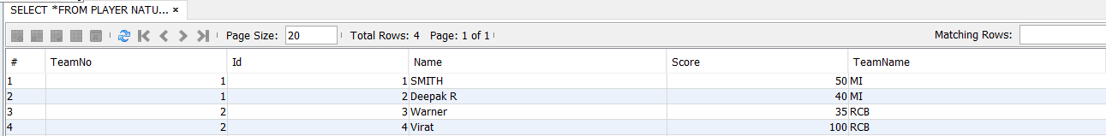

Figure 0‑7 players and team details in which TeamNo is same in both PLAYERS and TEAM (with natural join)

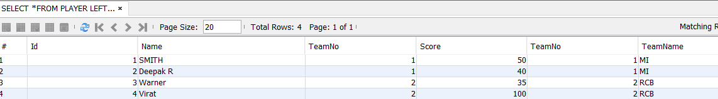

Figure 0‑8 players and team names in which TeamNo is same in both PLAYERS and TEAM (with left outer join)

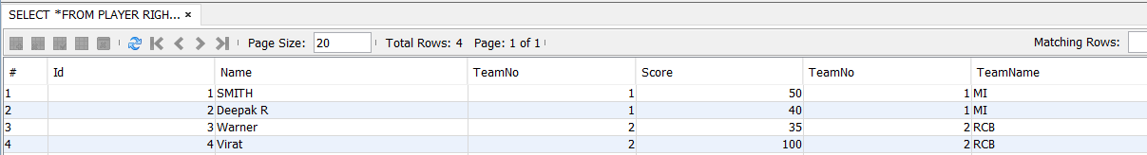

Figure 0‑9 team names and players involved in which TeamNo is same in both the PLAYERS and TEAM (with right outer join)

private void Button1ActionPerformed(java.awt.event.ActionEvent evt) {

// TODO add your handling code here:

try{

Class.forName("com.mysql.jdbc.Driver");

Connection conn = DriverManager.getConnection("jdbc:mysql://localhost/playerteam", "root", "root");

Statement st = con.createStatement();

ResultSet rs = st.executeQuery("SELECT Name FROM PLAYERWHERE TeamNo=(SELECT TeamNo FROM PLAYER WHERE NAME='SMITH')");

System.out.println("Name");

while(rs.next()) {

String Name = rs.getString("Name");

String table[] ={Name};

System.out.println("Name");

DefaultTableModel t=(DefaultTableMadel)z.getModel();

t.addRow(table);

*Figure 0-10 represents java program to display teammates of smith which is encoded in Display Button*

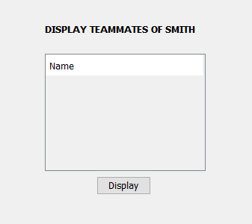

*Figure0-11 Design of front end*

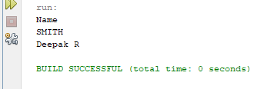

*Figure 0-12 Output for the above java Program*

1. **Conclusions**

A subquery can be nested inside other subqueries. SQL has an ability to nest queries within one another. A subquery is a SELECT statement that is nested within another SELECT statement and which return intermediate results. SQL executes innermost subquery first, then next level.

**Important Rule:**

* A subquery can be placed in a number of SQL clauses like WHERE clause, FROM clause, HAVING clause.
* You can use Subquery with SELECT, UPDATE, INSERT, DELETE statements along with the operators like =, <, >, >=, <=, IN, BETWEEN, etc.
* A subquery is a query within another query. The outer query is known as the main query, and the inner query is known as a subquery.
* Subqueries are on the right side of the comparison operator.
* A subquery is enclosed in parentheses.
* In the Subquery, ORDER BY command cannot be used. But GROUP BY command can be used to perform the same function as ORDER BY command.

1. **Comments**

**1. Limitations of Experiments**

In general, you cannot modify a table and select from the same table in a subquery. For example, this limitation applies to statements of the following forms:

DELETE FROM t WHERE ... (SELECT ... FROM t ...);

UPDATE t ... WHERE col = (SELECT ... FROM t ...);

{INSERT|REPLACE} INTO t (SELECT ... FROM t ...);

2**. Limitations of Results**

* The subquery_select_list can consist of only one column name, except in the exists subquery, where an (*) is usually used in place of the single column name. You can use an asterisk (*) in a nested select statement that is not an exists subquery.
* You cannot use subqueries in an order by, group by, or compute by list.
* Subqueries cannot manipulate their results internally, that is, a subquery cannot include the order by clause, the compute clause, or the into keyword.
* Correlated (repeating) subqueries are not allowed in the select clause of an updatable cursor defined by declare cursor.
* You cannot include a union clause in a subquery unless it is part of a derived table expression within the subquery.

3**. Learning happened**

We learnt how to use nested queries and different types of joins in SQL